**Assignment 4**

Q1. Notch the noise component in the image given below (left), the corresponding centered magnitude spectrum is given towards the center, and filtered image is given on right. You should show both noise and filtered image. [4]

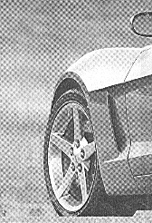 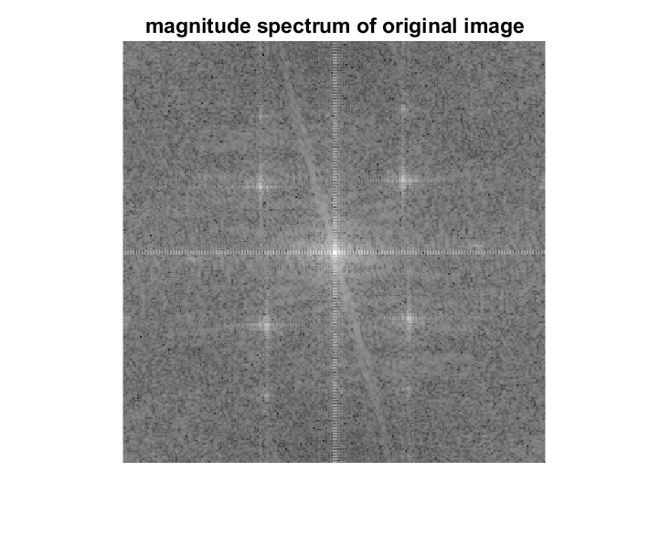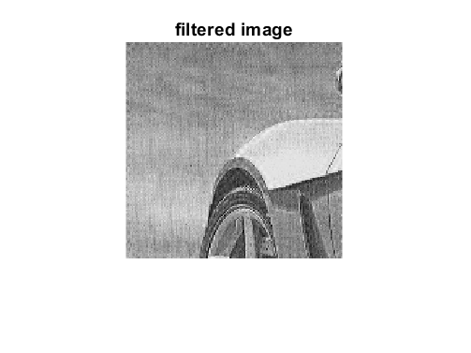

Q2. Consider the image degradation model $g=h*f+ η$

Inverse filtering in spatial domain is given by $f_{est}={(H'H)}^{-1}H'g$**,** where $f_{est}$ denotes the estimated image, $H$ denotes the block circulant matrix and is known, and $g$ denotes the observed image. The solution is obtained by minimizing ${\left\|g-Hf\right\|}^{2}$ wrt. $f$**.**

Equivalently, the convolution operation in Fourier domain can be written as ${\left\|G-HF\right\|}^{2}=\sum_{k}{\sum_{l}{{\left|G\left(k,l\right)-H(k,l)F(k,l)\right|}^{2}}}$, where $H$ is the Fourier transform of $h$. Now let us say, we have to minimize ${\left\|G-HF\right\|}^{2}+{λ\left\|F\right\|}^{2}$ = $\sum_{k}{\sum_{l}{{\left|G\left(k,l\right)-H(k,l)F(k,l)\right|}^{2}+λ{\left|F(k,l)\right|}^{2}}}$

Find ***F.***  [4]

Q3. Use the filtered image from Q1. Given, $H\left(k,l\right)=e^{-c{(k+l)}^{}}k,l=0,1,…511;$, $c=.002$, apply this filter in the Fourier domain and then perform inverse filtering. Observe if you are able to get the input image back.

Now add AWGN to the degraded image and again repeat inverse filtering. What do you observe? Show all images. [2]

Ungraded

Q4. Solve for $f by minimizing {\left\|g-Hf\right\|}^{2}+λ{\left\|f\right\|}^{2}$.

Note: For Fourier domain filtering

1. Zero pad image to twice its size. Then build the notch filter of this size.
2. Multiply the two matrices elementwise.
3. Take ifft, real and then crop original image’ size from top-left.